**UNIVERSITY FOR DEVELOPMENT STUDIES**

**(UDS)**

FACULTY OF MATHEMATICAL SCIENCES

DEPARTMENT OF COMPUTER SCIENCE

DESIGN AND IMPLEMENTATION OF A TIMETABLE DRAFTING AND MANAGEMENT SYSTEM

PRESENTED TO:

SIR STEVEN AKOBRE

BY:

**MAHMUD SULEMAN SHEIKH WUNNAM**

**FMS /0131 / 16**

**JULY, 2020**

# EXECUTIVE SUMMARY

Scheduling of tasks is very important in every institution and the University for Development Studies is not an exception. For this reason, the University for development studies has a timetabling system with which it uses to schedule lecturer halls for examination and lectures. The objective of the project is to simplify things for the student body when it comes to drafting specific courses from the timetable concerning the courses a student has registered for the trimester. The above-mentioned project presents to the student's body a website from which students will just have to provide a few details about themselves and they are guaranteed to have a well-formatted and drafted timetable according to the courses they have registered.

Due to the little available time frame, the design process of the website focused on the Rapid Application Development approach of system design whereby interactive prototypes where designed and few users reviewed so that necessary changes were made.

In conclusion, the system is expected to ease the hardship the students face when it comes to getting a timetable based on the courses they have registered for the trimester and also updating the personal drafted timetable when there is an update on the school timetable in general.

# ACKNOWLEDGEMENT

First of all, I am grateful to God Almighty for the good health and wellbeing that were necessary to complete this project. I wish to express my sincere gratitute to Sir Stephen Akobre, lecturer in the Computer Science Department, for providing me with all the necessary assistance and guidance for this project work.

I would also like to extend my gratitude to one and all, who directly or indirectly, especially my friends and family for all the support from the very beginning.

# TABLE OF CONTENT

Contents

EXECUTIVE SUMMARY ii

ACKNOWLEDGEMENT iii

TABLE OF CONTENT iv

CHAPTER ONE 1

1.1 INTRODUCTION 1

1.2 PROBLEM STATEMENT 2

1.3 OBJECTIVES OF THE STUDY 2

1.4 SIGNIFICANCE OF STUDY 3

1.5 SCOPE OF THE STUDY 3

1.6 LIMITATIONS OF THE STUDY 3

CHAPTER TWO 4

LITERATURE REVIEW 4

2.1 INTRODUCTION 4

2.2 RELATED WORKS 4

2.2.1 AUTOMATIC TIMETABLE GENERATION USING GENETIC ALGORITHM 4

2.2.2 AUTOMATING CLASS SCHEDULE GENERATION IN THE CONTEXT OF A UNIVERSITY TIMETABLING INFORMATION SYSTEM 5

2.2.3 INTEGRATED THREE-TER APPLICATION FRAMEWORK WITH AUTOMATED CLASS AND TABLE GENERATION 6

2.2.4 A PARALLEL GENETIC ALGORITHM FOR SOLVING THE SCHOOL TIMETABLING PROBLEM 7

2.2.5 SCHOOL MANAGEMENT SYSTEM 7

2.2.6 THE RESEARCH ON BIG DATA PLATFORM BASED ON TIMETABLE MANAGEMENT 8

CHAPTER THREE 9

3.1 SYSTEM DESIGN METHODOLOGY 9

3.2 TOOLS AND TECHNOLOGY USED 11

3.2.1 HTML, BOOTSTRAP, AND CSS 11

3.2.2 PHP AND MYSQL 11

3.2.3 JAVASCRIPT, AJAX AND JQUERY 11

CHAPTER FOUR 13

4.1 DESIGN AND IMPLEMENTATION OF THE SYSTEM. 13

4.2 SPECIFICATION ANALYSIS. 13

4.2.1 HARDWARE REQUIREMENTS. 13

4.2.2 SOFTWARE REQUIREMENT. 13

4.3 DATABASE DESIGN. 14

4.4 SYSTEM SCOPE. 15

4.5 SYSTEM INTERFACE DESIGN AND USAGE. 16

4.5.1 THE LANDING PAGE. 16

4.5.2 ABOUT SECTION. 17

4.5.3 USER DETAILS FORM. 18

4.5.3 THE ADMIN SECTION 19

REFERENCES 25

# **LIST OF FIGURES**

Figure 1: database sample 14

Figure 2: Landing page of the website 16

Figure 3: About section 17

Figure 4: User details form 18

Figure 5:Administrator Section 19

Figure 6:import timetable data 20

Figure 7: import courses data 21

Figure 8: Import courses data error reporting 22

Figure 9: Courses search result sample 23

Figure 10: timetable data search sample 24

Figure 11: Update course data form sample 25

Figure 12: Update timetable course data form sample 26

Figure 13: Timetable courses search sample 27

Figure 14: Generated timetable sample in pdf format. 27

# CHAPTER ONE

## 1.1 INTRODUCTION

A timetable is a kind of schedule that sets out times at which specific events are intended to occur (“Timetable (disambiguation) - Wikipedia,” n.d.). Scheduling of tasks is very important in every institution, the university(University for Development Studies), therefore, has a timetable generating system which they use for scheduling courses for every program. The timetable system makes it simple for the school to get a timetable ready for everyone. On the other hand the issue of the general timetable of the University for Development Studies, Navrongo campus being difficult and confusing to read has been around from the very first beginning and the reason as to why it has not been resolved yet is unclear, perhaps no one has ever seen it to be a bigger problem enough which is indeed a problem to be addressed because students sometimes missing lectures and also students having to leave their hostel and go to campus just to check on updates which have been made on the timetable.

Students do not have to keep referring to the general time table each time they want to check their lecture schedule. The student body especially the level 100s finds it difficult reading and drafting a timetable for the courses they have registered whenever there is a new timetable or when there is an update in the lecture schedules which results from allocation of wrong times to some lectures which may lead to them missing certain lectures.

This project aims to address these issues so that the student can have their timetable with them all the time without worrying about any updates when there is any, by presenting to the student body

a web-based application (website) where they will only have to visit and specify the courses they have registered and will be able to print out a drafted copy of the timetable based on the courses they have registered.

When the proposed innovation is implemented, students and lecturers will not have to worry whenever a timetable is being released whenever there is an update in the school’s already existing timetable.

## 1.2 PROBLEM STATEMENT

The traditional way of students getting access to a new or updated timetable needs to be reconsidered which is the fact that the student body will have to visit the notice board almost always just to see if there is or has been a change in the lectures schedule. To make scheduling of lectures well organized and structured, the university for development studies has a timetable management system that is responsible for the scheduling of lectures and exam times. Though it is in place to make things simple, most of the time, schedules keep changing during the trimester. When there is a sudden change in the lecture timetable, students tend to miss lectures for not being notified. On several occasions, lecturers have missed lectures because they do not know the timetable being changed. With the proposed solution which is a web application, the students and lecturers wouldn’t have to worry at all about changes in the timetable.

## 1.3 OBJECTIVES OF THE STUDY

* To make timetable drafting much simpler
* To possibly reduce the missing of lectures due to a sudden change in the lecture schedule
* Student don’t have to visit notice board all the time for updates on timetable
* Easy access to timetable anywhere

## 1.4 SIGNIFICANCE OF STUDY

As part of the school’s academic activities, every final year student is to a list of project works the find worth tackling to their assigned supervisors and after project work is decided, the student is expected try and present a feasible solution of their proposed project as a report and a full-function application (if available). This project aims at solving the problem faced by the student body when it comes to getting a drafted timetable based on the courses they have registered for a trimester.

## 1.5 SCOPE OF STUDY

The research is based on the design and implementation of a web-based timetable drafting and management system for the computer science department of the University for Development Studies.

## 1.6 LIMITATIONS OF THE STUDY

Throughout the research, a lot of challenges were faced. The time factor was a great challenge as the little time frame for the completion of the work didn’t give the researcher much opportunity to explore the problem stated in detail. Another limitation was the COVID-19 pandemic as there was a need for social distancing and other factors like the school being closed until further notice. Financial constraint was yet another challenge faced during the research period.

# CHAPTER TWO

## LITERATURE REVIEW

## 2.1 INTRODUCTION

Time is a very delicate entity in our daily lives and there is a need to plan out things very well to make the most out of it. Resources, on the other hand, is not always available as compared to the demand rate so there is the need for proper scheduling of tasks to make the most of the limited resources available. In other to make resources available to every student in the university for development studies, the school employs a way to schedule lecture halls to each class of students based on certain criteria. The school uses a timetable system which is responsible for scheduling lectures and lecturer hall appropriately for the students and lecturers. The said time table system is to make scheduling easier for the school management and it has served its purpose. On the other hand, on the part of the students, it hasn’t since most of the students find it “very” difficult reading and drafting their courses for which they have registered. When there are new or updates on the timetable, the student body has to make their way to the notice board where a copy of the timetable is pasted to go through and make changes that have affected their lecture schedules which is a disadvantage to the students.

## 2.2 RELATED WORKS

### 2.2.1 AUTOMATIC TIMETABLE GENERATION USING GENETIC ALGORITHM

In this thesis, an evolutionary algorithm, a genetics algorithm for timetabling was proposed. The algorithm intended to generate a time-table schedule automatically which was satisfied. The algorithm incorporates several techniques, aimed to improve the efficiency of the search operation. By automating this process with the help of a computer assistance timetable generator can save a lot of precious time for administrators who are involved in creating and managing various timetables of the institutes. Also, the timetables generated are much more accurate, precise than the ones created manually. They used C# along with the .NET framework to develop their application. They used real data from various departments of the institution to test the method and how effectively it is functioning. The project reduces time consumption and the pain in framing the timetable manually. The benefits of this approach are simplified design and reduced development time (Mittal, Doshi, Sunasra, & Nagpure, 2015).

### 2.2.2 AUTOMATING CLASS SCHEDULE GENERATION IN THE CONTEXT OF A UNIVERSITY TIMETABLING INFORMATION SYSTEM

This thesis has examined the timetable scheduling problem. It began with a discussion into the terminology and size of the research area. A strong distinction between the terms scheduling and timetabling was made to avoid confusion in the work presented.

From these trends, objectives for the research were developed and a proposed information system to support all aspects of university teaching was developed. Its uniqueness, in being derived and built on a foundation of supporting timetable generation, was highlighted. Screen dumps of most of the fundamental data entry screens for implementation of this system highlighted the seamless integration of an information system that supported not only research activity but also transactional administrative functions. An initial evaluation by several interested parties, especially users, although necessarily conducted in a purely exploratory manner, provided positive feedback. This feedback included comments regarding the ease of use of the system. The system that was developed produced outcomes that were expected and hence met the requirements set by the objectives(Sandhu, 2001).

### 2.2.3 INTEGRATED THREE-TER APPLICATION FRAMEWORK WITH AUTOMATED CLASS AND TABLE GENERATION

An integrated three-tier application framework with automated class and database table generation. Schema information in the form of metadata Structures is used to generate data classes for the client tier and the application tier. Corresponding client tier and application tier data classes implement a common interface that Supports generalized access by other System components. Based on the Schema information, factory classes are automatically generated for the client tier and application tier which permit instantiation of the generated data classes. Also, database configuration is automated by the generation of database table creation commands from the Schema information. In one embodiment, a framework of management components is provided for both the client and application tiers to handle inter-tier communication, transparent caching of data objects in a public Store, handling of changes to data via change objects, handling of updates in response to data changes, and resolution of query objects into database queries. Common methods are generated within each data class which recognizes the use of a public Store and the application of a change object Scheme. Further, methods and attributes are inherited from framework Super-classes that identify and interface with a public Store, and that confer the concept of identity on a data class, as well as the ability to discover the attributes of the data class(Brian, Andy Kittridge, Kevin, Chiaming, & Vanessa, n.d.).

### 2.2.4 A PARALLEL GENETIC ALGORITHM FOR SOLVING THE SCHOOL TIMETABLING PROBLEM

Genetic algorithms (GA) have been applied to several optimization problems with some success. The algorithms mimic the process of natural selection, with the effect of creating several potentially optimal solutions to some complex search problems. One of the major disadvantages of genetic algorithms is that they are very slow. In this paper, they discussed the application of a GA to the school timetabling problem, and show how the execution time can be reduced by using a commercial shared-memory multiprocessor. The paper reports some results from the sequential execution of the algorithm as well as the speedup attained from the parallel solution(Abramson & Abela, 1991).

### 2.2.5 SCHOOL MANAGEMENT SYSTEM

In this project, they developed an automated school management system that facilitates the various activities taking place at schools. The system developed in the project consists of windows and web applications. These are two different applications on the same database. The windows application takes most of the activities such as offline student registering, transcript and report card generation, and producing the timetable. The web application facilitates attendance recording by the homeroom teachers and to view reports, to view the status of students by students, teachers, and parents. Our solution to the timetabling problem is very simple. Data structures are used to implement the timetable designed. The scheduler selects a subject-teacher from the database, retrieves all the classes assigned to the teacher, calculates the load of the teacher which cannot be greater than the maximum load and selects one of the days randomly based on the number of lessons of the subject, searches a free appropriate time slot and assigns the slot to the lesson. The scheduler repeats the process until the load of the teacher becomes zero and all the teachers in the database are visited. Finally, the result generated is stored in a database. The prototype has been tested with data from Kokebe Tsebah Secondary School. It has been shown that the system effectively registers students along with parental information, easily retrieves information about a student, and generates the required reports such as a transcript, report card, and timetable. In addition to generating a feasible master timetable, it produces a timetable for each teacher. Furthermore, it has been shown that the web application of the system helps attendance recording by the homeroom teacher and parents can view the status of their children using the Internet or Intranet of the school(Teka, 2008).

### 2.2.6 THE RESEARCH ON BIG DATA PLATFORM BASED ON TIMETABLE MANAGEMENT

The timetable is the core technical plan of the railway transportation organization, and it is the basis for the daily work. However, at present, China's timetable management technology is relatively backward, which cannot meet the safety and efficiency of actual transportation. This paper analyzes the problems in the current situation of timetable management. Starting from the problem, the application research of big data platform is proposed. Firstly, the data is collected and normalized, then the safety analysis and index analysis are carried out, and finally, the intelligent optimization is carried out(Xu et al., 2019).

# CHAPTER THREE

## 3.1 SYSTEM DESIGN METHODOLOGY

Rapid application development (RAD) is a software development methodology, which involves iterative development and the construction of prototypes. Rapid application development is a term originally used to describe a software development process introduced by James Martin in 1991.

The basic principles are:

The most important objective is to develop and deliver high-quality systems fast and at a relatively low cost

This approach breaks the project into smaller segments for ease-of-change during development process which reduces inherent project risk

This approach uses iterative Prototyping to get active user involvement and computerized development tools. These tools may include code generators, Computer-Aided Software Engineering (CASE), Graphical User Interface (GUI) builders, , Database Management Systems (DBMS), and many more.

Unlike the Waterfall method, integrations are included early in the software development process in the RAD approach.

Project control involves prioritizing development and defining delivery deadlines or “timeboxes”. If the project starts to slip, the emphasis is on reducing requirements to fit the timebox, not in increasing the deadline.

Generally, the RAD approach includes joint application design (JAD), where users are intensely involved in system design.

The RAD approach focuses on five steps.

* Define and finalize project requirements
* Begin building prototypes
* Gather user feedback
* Test, test, test
* Present your system

(“What Is Rapid Application Development (RAD)?,” n.d.)

(Boehm, 1986)

## 3.2 TOOLS AND TECHNOLOGY USED

For a project of this sort to be successful, a lot of tools were used. Below are the tools used.

### 3.2.1 HTML, BOOTSTRAP, AND CSS

Hypertext Mark Language (HTML) is a mark language used in defining how the data on a web page will be formatted. This is used to render all the data seen on the web pages.

the Cascading Style Sheet Sheet (CSS) is used to design the look and feel of web pages. CSS controls the beauty of the web pages.

Bootstrap is a free and open-source CSS framework directed at responsive, mobile-first front-end web development. It contains CSS and (optional) javascript-based design templates from typography, form, buttons, navigation, and other interface components(“Bootstrap (front-end framework) - Wikipedia,” n.d.).

### 3.2.2 PHP AND MYSQL

There is a need for data storage in the application and this is made possible with the help of PHP and MySQL database. PHP is the interface used to communicate with the database engine. The PHP runs on a server. The MySQL database was chosen for its simplicity. With PHP and MySQL data, dynamic data can be rendered to the user based on their interaction with a web application.

### 3.2.3 JAVASCRIPT, AJAX AND JQUERY

Javascript is one of the core technologies of the world wide web and it is used alongside HTML and CSS. Javascript enables an interactive web page and is an essential part of the web applications. The vast majority of websites use it for client-side page behavior, and all major web browsers have a dedicated javascript engine to execute it. Jquery on the other hand is a javascript library that is intended to simplify javascript code and takes care of most of the workload for the developers. On a web page, there are times a data has to be returned to the user without the need to refresh the whole web page and that’s when Ajax comes into play. With Ajax, web applications can send and retrieve data from a server asynchronously (in the background) without interfering with the display and behavior of the existing page. By coupling the data interchange layer from the presentation layer, Ajax allows web pages and, by extension, web application, to change content dynamically without the need to reload the entire page(“JavaScript - Wikipedia,” n.d.).

# CHAPTER FOUR

4.1 DESIGN AND IMPLEMENTATION OF THE SYSTEM.

System design is the process of defining the architecture, modules, interfaces, and data for a system to satisfy specified requirements. This could be seen as the theory behind the system to be built. System implementation (i.e. physical system building) on the other hand is the process of building the system and making sure the system is operational and meets quality standards as specified(“System Architecture | Nortik Software Solutions,” n.d.).

## 4.2 SPECIFICATION ANALYSIS.

This is a critical step to ensure the success of the development of the system. Here we take into consideration the system on which the final project will be run and the system to use in the development of the project.

This project is built to run on systems with the following specification:

### 4.2.1 HARDWARE REQUIREMENTS.

* 512MB of minimum RAM
* 10GB of minimum Hard Disk Capacity

### 4.2.2 SOFTWARE REQUIREMENT.

* Windows operating system (Win2000, WinXP, WinVista or above)
* PHP server. Eg (XAMPP SERVER Setup)
* MySQL setup eg (XAMPP SERVER Setup)
* Web browser (Google Chrome, Mozilla Firefox, Opera, Microsoft Edge, etc )

## 4.3 DATABASE DESIGN.

A database is an organized collection of data, generally stored and accessed electronically from a computer system (“Database - Wikipedia,” n.d.). To create and use databases in the project, a Relational Database management system was used. A Database management system, therefore, is the tool that helps in creating and managing data stored in the database. Some of the basic operations provided by database management systems are created (inserting data to the database), read ( retrieving data from the database), update ( updating data in the database), and delete (deleting unwanted data from the database).

Some of the benefits derived from using a database management system to the project are as follows;

* Improved data sharing
* Improved data security
* Better data integration
* Better data storage
* Better data management
* Minimized data inconsistency
* Improved ease of data access
* Improved decision making

Sample database;

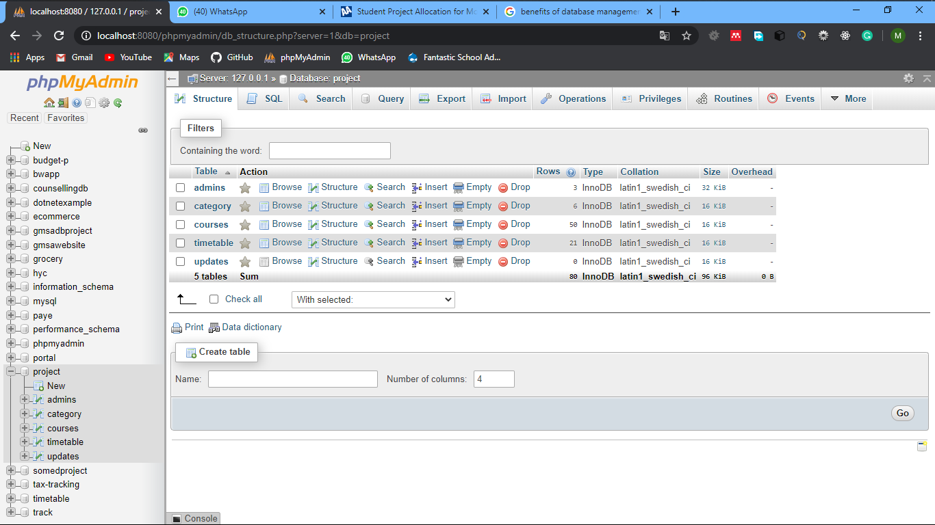

Figure : database sample

The above figure is the database structure of the project. It consists of 5 tables.

* The admin table stores the data of the administrator(s) of the project
* the category table stores information about the various department,
* the courses offered and the levels associated with each program offered,
* the course table store data about the courses offered in University for development studies
* the timetable table stores data about the current trimester timetable
* updates table store information about changes that have happened on the timetable and when it happens

## 4.4 SYSTEM SCOPE.

This timetable extraction and management system are designed purposely for the UDS Navrongo campus. It is aimed at simplifying the general timetable for the student body. The simplicity of the project was considered whilst building it. Its usage is so simple that all that you need is a working device (mobile phone or computer) with an active internet connection. The user just has to log on to the system specify what faculty, department, program offered, courses they have registered and they will have a well-formatted and extracted timetable without any problem.

## 4.5 SYSTEM INTERFACE DESIGN AND USAGE.

The system consists of several components that work together to bring about rich and easy to use user experience. The system is so user friendly that users do not need any special training before they can use the system. The system anyway, requires an administrator to coordinate the data entries and data management processes. Thus the administrator(s) has to make sure courses are uploaded and updated whenever there is a change in data on the timetable and courses.

### 4.5.1 THE LANDING PAGE.

Below is the first thing you will see when you log onto the system. A little intro message describing the system and an extract now button. When users are not sure of how to proceed with their timetable extraction process, they just click the button and they will be redirected to a form where they will provide their details and their timetable will be ready for them to download.

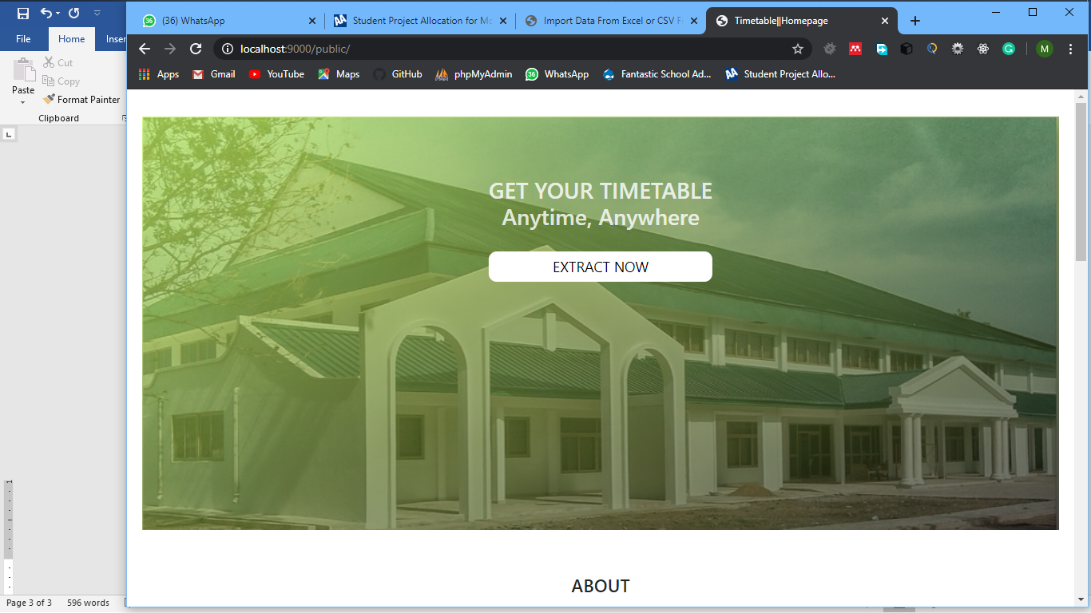

Figure : Landing page of the website

### 4.5.2 ABOUT SECTION.

This section of the home page consists of two sections. Firstly, it has instructions about how to go about and extract your timetable. The user is walked through about what data they need to get their timetable ready and also where to fill that data. the second section of the about section is the updates section. Here, whenever there is an update on the timetable, the updates appear. When there is an update on the time table and the user logs onto the system they will check here to see if the changes have affected any course they do. If it does, the go about extracting a new one else the logout.

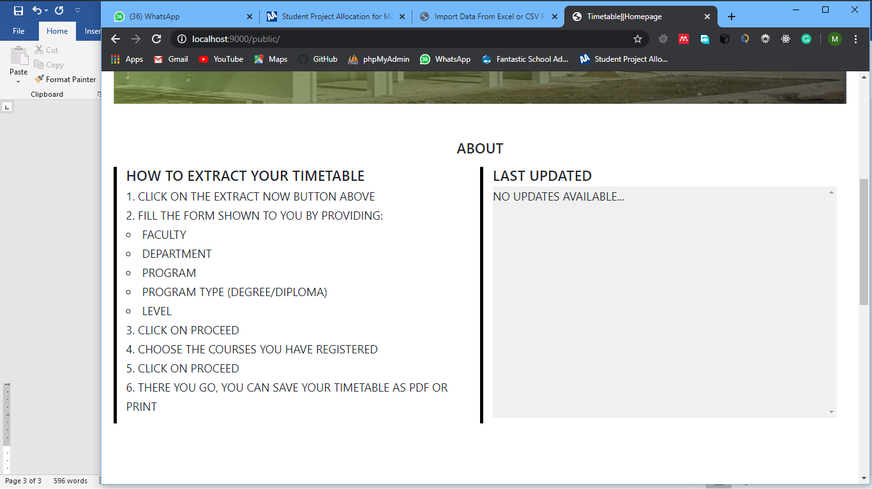

Figure : About section

### 4.5.3 USER DETAILS FORM.

In this section, the user provides all the necessary details needed by the system to be able to provide a personalized timetable for the user with ease. The user provides data like faculty, program, program type, and level. With these data, the system will be able to prepare for the user a customized timetable without any problem. All the fields are required and the user will have to provide all the information before they can continue. After the user is done, they will have to click on the proceed button to continue.

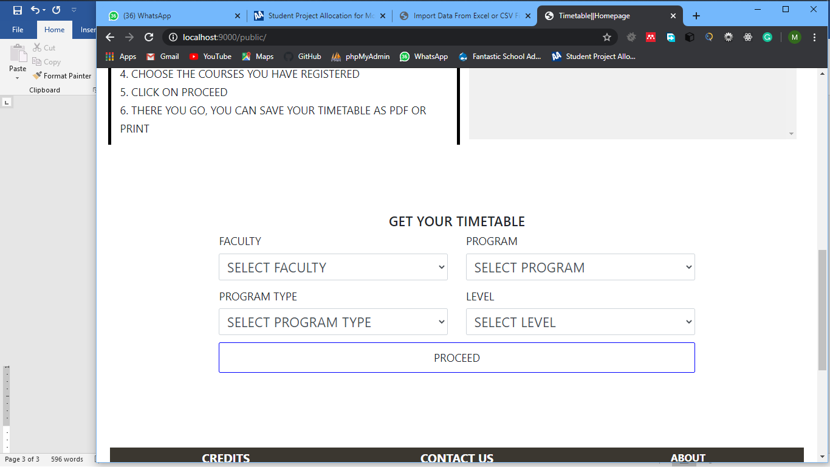

Figure : User details form

### 4.5.3 THE ADMIN SECTION

The admin section consists of a navigation bar at the top which contains 4 navigation menus, a drop-down list, a search box, and the current user username. First of the navigation menu is a ‘add trimester course’ menu; with this, the administrator can upload the trimester courses one by one. The second navigation menu is the ‘add timetable courses’ from which the administrator can upload the time table courses one by one. Uploading courses one after the other would be a tedious task to do by the administrator and to counter this problem, menu three and four are import options. From options three and four, the administrator can upload courses and timetable data from either a CSV or Excell files.

Another feature of the administrator page is the search field. The administrator type in the course they want and it appears in the search area below and the administrator can now choose to either update that course or delete it.

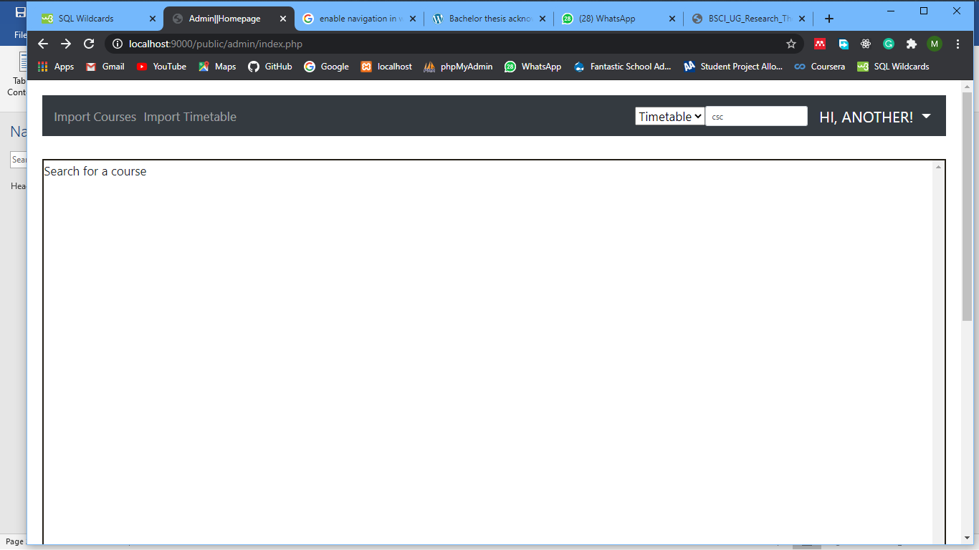

Figure :Administrator Section

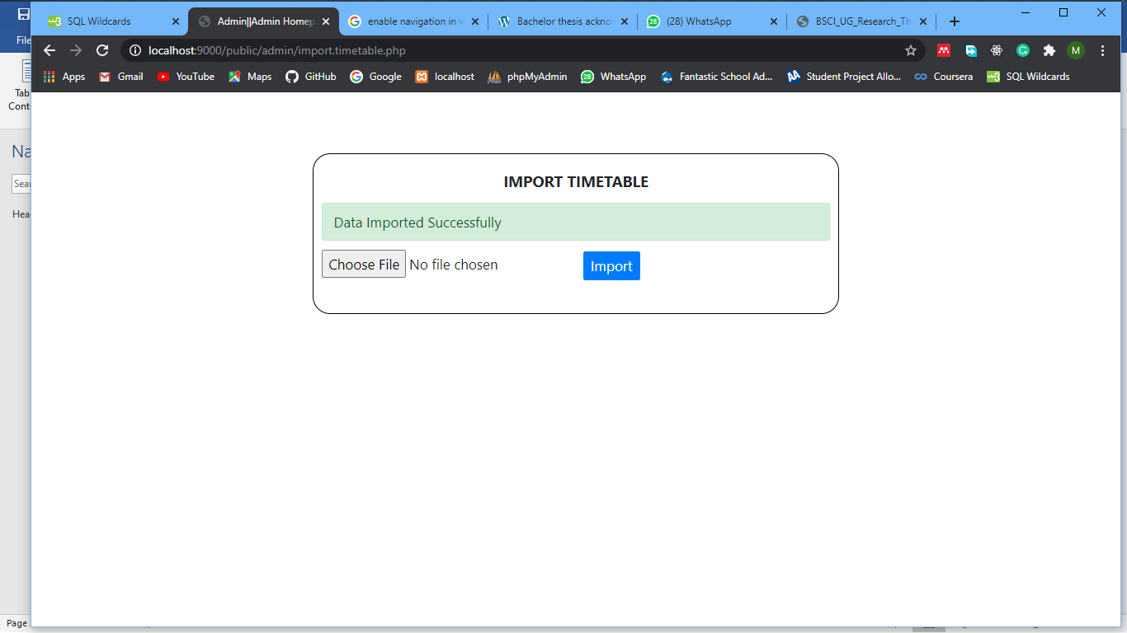

Figure :import timetable data

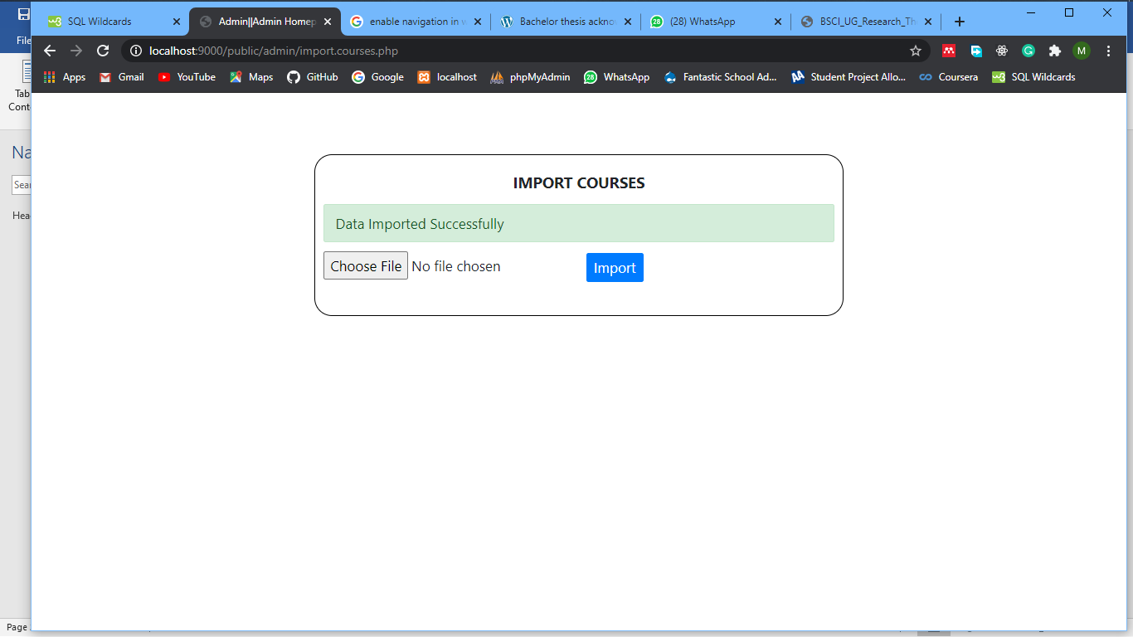

Figure : import courses data

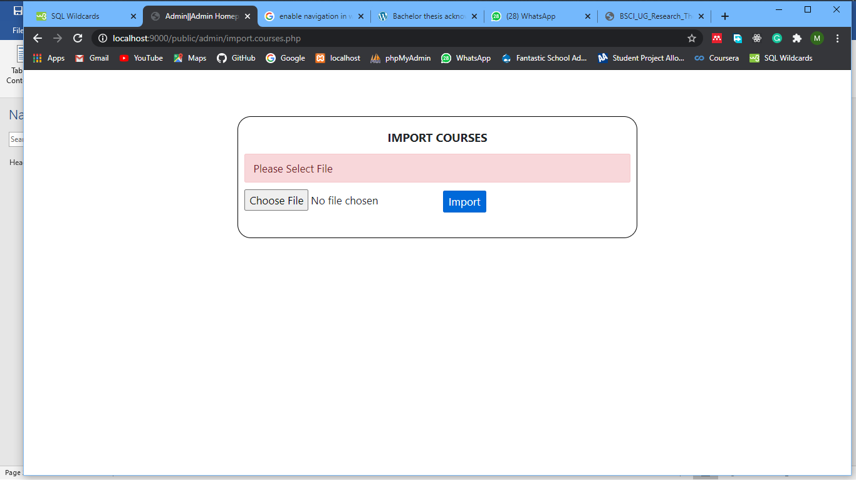

Figure : Import courses data error reporting

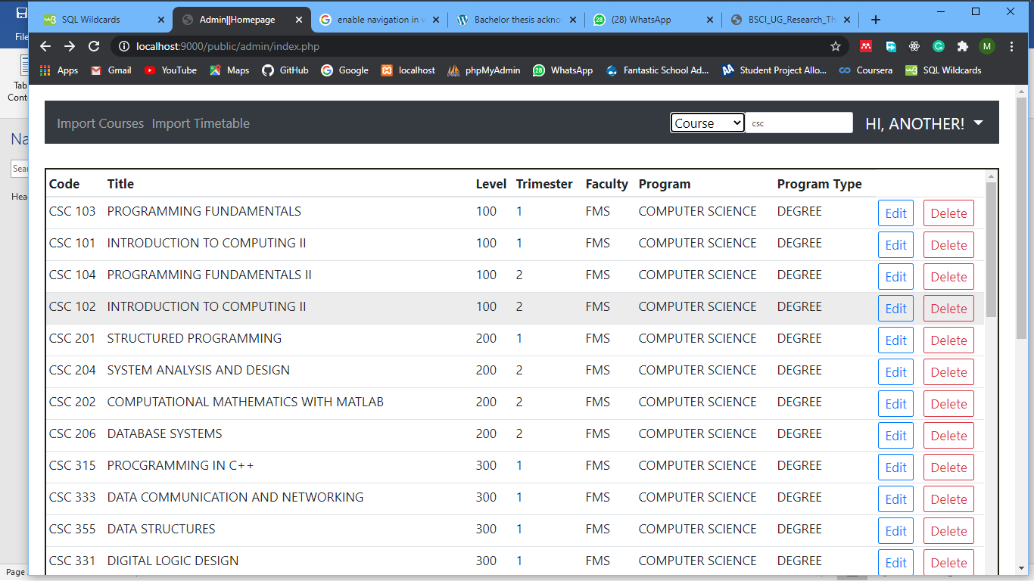

Figure : Courses search result sample

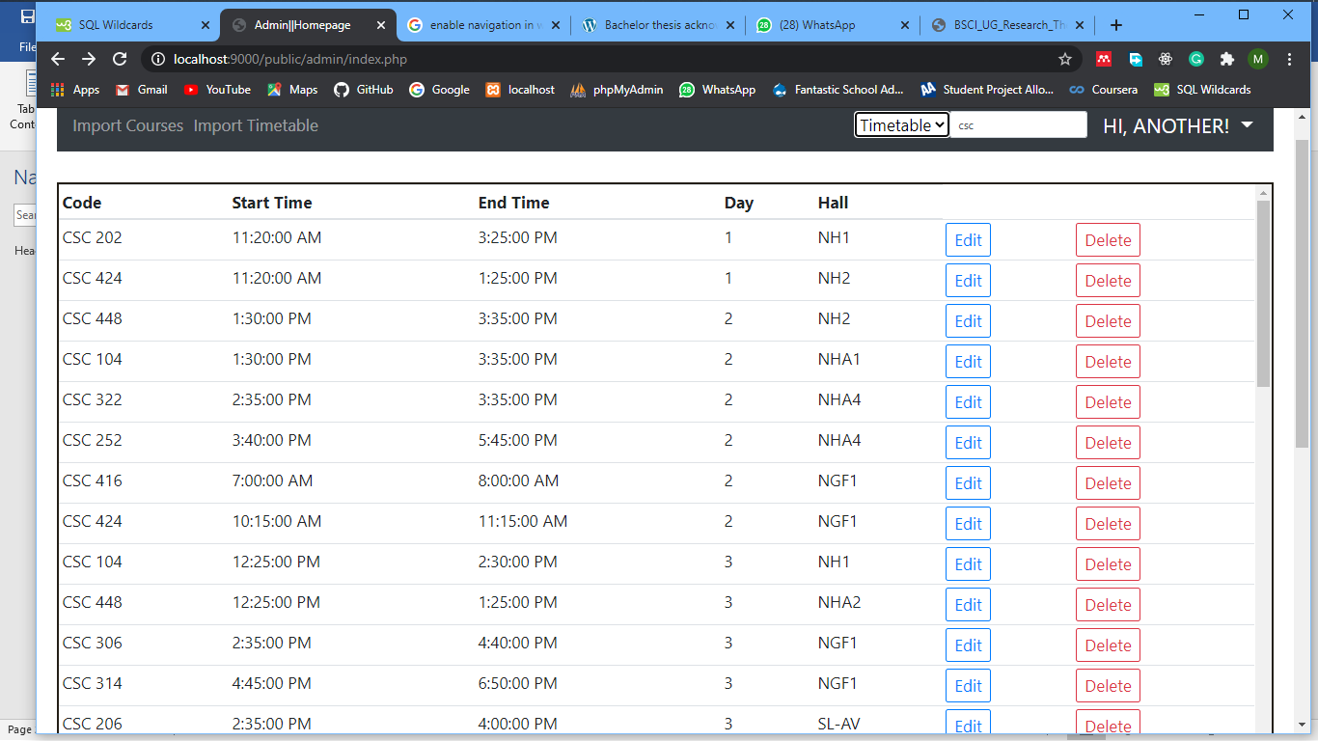

Figure : timetable data search sample

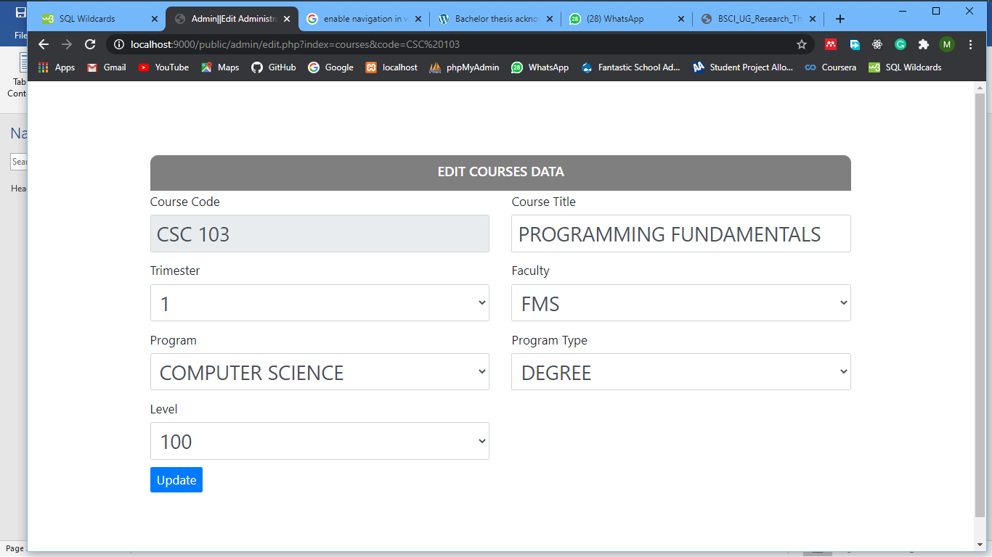

Figure : Update course data form sample

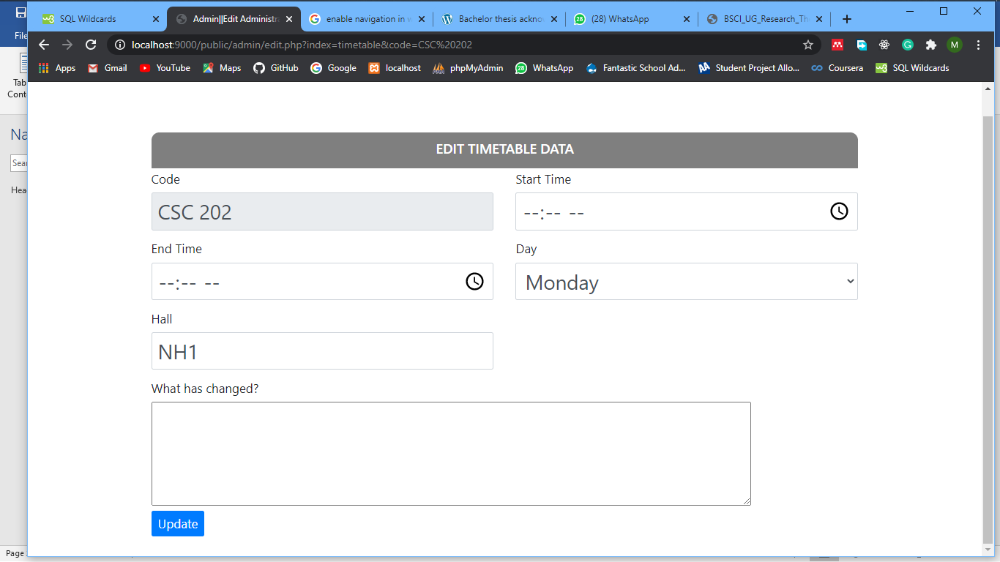

Figure : Update timetable course data form sample

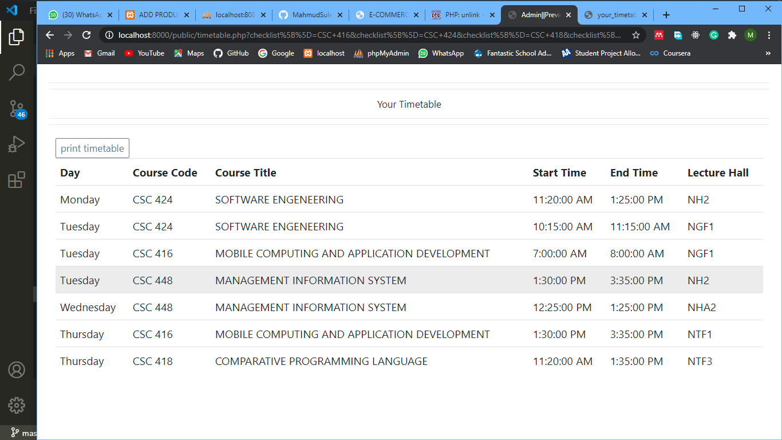

Figure : Timetable courses search sample

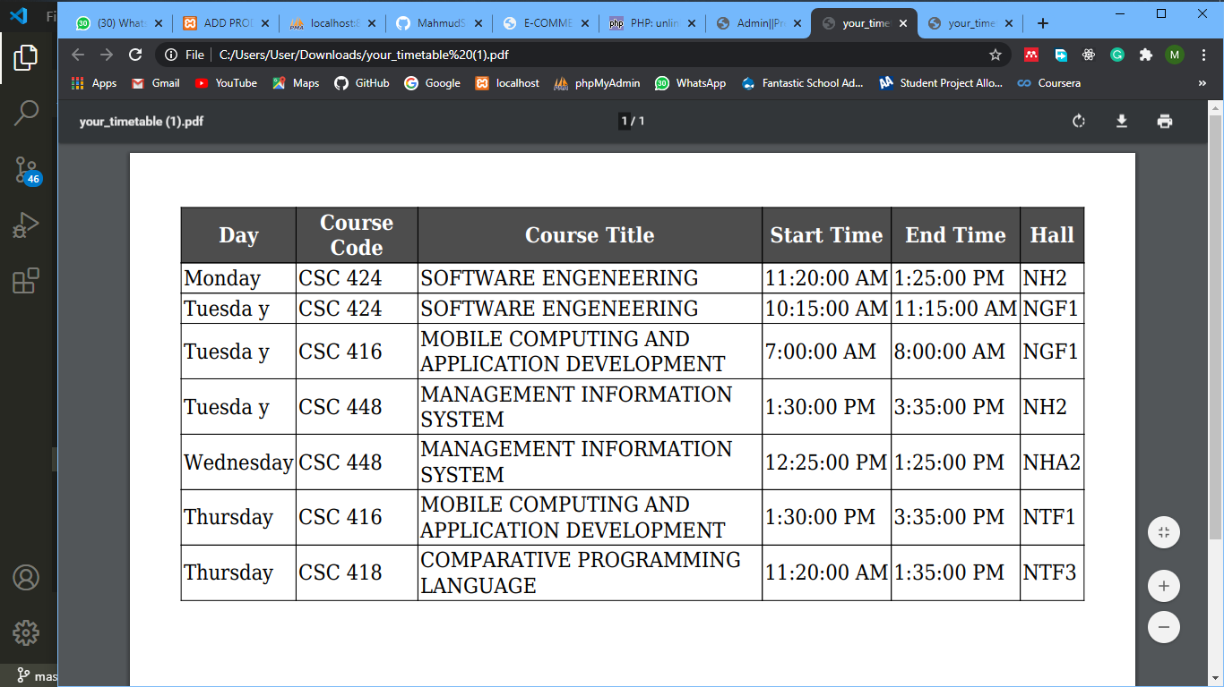

Figure : Generated timetable sample in pdf format.

# CHAPTER FIVE

## 5.1 CONCLUSION

## 5.2 RECOMMENDATION

# REFERENCES

Abramson, D., & Abela, J. (1991). A parallel genetic algorithm for solving the school timetabling problems. *Proceedings of the First International Workshop on Parallel Processing for AI*, 6–11.

Boehm, B. (1986). A spiral model of software development and enhancement. *ACM SIGSOFT Software Engineering Notes*, *11*(4), 22–42. https://doi.org/10.1145/12944.12948

Bootstrap (front-end framework) - Wikipedia. (n.d.). Retrieved July 25, 2020, from https://en.wikipedia.org/wiki/Bootstrap_(front-end_framework)

Brian, S., Andy Kittridge, T., Kevin, M., Chiaming, Y., & Vanessa, M. (n.d.). *INTEGRATED THREE-TERAPPLICATION FRAMEWORK WITH AUTOMATED CLASS AND TABLE GENERATION*. (19).

Database - Wikipedia. (n.d.). Retrieved July 25, 2020, from https://en.wikipedia.org/wiki/Database

JavaScript - Wikipedia. (n.d.). Retrieved July 25, 2020, from https://en.wikipedia.org/wiki/JavaScript

Mittal, D., Doshi, H., Sunasra, M., & Nagpure, R. (2015). Automatic Timetable Generation using Genetic Algorithm. *Ijarcce*, *4*(2), 245–248. https://doi.org/10.17148/ijarcce.2015.4254

Sandhu, K. (2001). *Automating Class Schedule Generation in the Context of a University Timetabling Information System*. (319995), 201.

System Architecture | Nortik Software Solutions. (n.d.). Retrieved July 25, 2020, from https://www.nortiksoftware.com/systemarchitecture.html

Teka, D. (2008). By Degif Teka. *Screen*, (June).

Timetable (disambiguation) - Wikipedia. (n.d.). Retrieved June 10, 2020, from https://en.wikipedia.org/wiki/Timetable_(disambiguation)

What Is Rapid Application Development (RAD)? (n.d.). Retrieved July 25, 2020, from https://blog.capterra.com/what-is-rapid-application-development/

Xu, T., Zhou, L., Bai, Z., Li, W., Guo, B., & Wang, Z. (2019). The Research on Big Data Platform based on Timetable Management. *IOP Conference Series: Materials Science and Engineering*, *569*(5). https://doi.org/10.1088/1757-899X/569/5/052081